LAB - SWR302

Name: Nguyễn Thị Thúy Quỳnh
Roll Number: HE204152
Class: SE2035-JV

- Use Cases

UC ID and Name: | UC57- Create Purchase Proposal
Created By: | QuynhNTT | Date Created: | June 3, 2026
Primary Actor: | Sales Staff | Secondary Actors: | NONE
Trigger: | Sales Staff selects to create a new purchase proposal from the proposal management screen.
Description: | This use case allows the Sales Staff to create a new purchase proposal for buying devices.
Preconditions: | - The Sales Staff has successfully logged into the system.  - The Sales Staff has permission to create purchase proposals.
Postconditions: | - A new purchase proposal is created with "Pending" status, waiting for Sales Manager approval.
Normal Flow: | 1. Sales Staff navigates to the purchase proposal management feature.  2. Sales Staff requests to create a new purchase proposal.  3. System presents a form for entering proposal details (items, quantities, estimated prices, supplier, notes…).  4. Sales Staff fills in the proposal information.  5. Sales Staff submits the proposal.  6. System validates that all required fields are provided.  7. System saves the proposal and displays a success message.
Alternative Flows: | At step 3, instead of manually entering items,  - Sales Staff chooses to import from a Excel file.  - System parses the file and pre-fills the item list.  - Sales Staff reviews and adjusts the imported data.  - Return to step 5 of normal flow.
Exceptions: | E1: At step 6, if required fields are missing, system prevents submission and displays an error indicating which fields are missing.  E2: At step 6, if staff enters quantity smaller than 0, system prevents submission and requests to enter again.
Priority: | 2 - High
Frequency of Use: | 2 -Weekly
NFR: | - Security: Only accounts with the purchase_proposal.create privilege can execute this request. Any unauthorized attempt must be rejected immediately without exposing the creation interface.  - Performance: The proposal creation and validation must complete within less than 3 seconds.
Business Rules: | At step 4: Each proposal must contain at least one item with a specified quantity and estimated price.  At step 4: The device quantity must be greater than zero.
Other Information: | This use case is the starting point of the procurement process. All purchase orders are derived from approved proposals.
Assumptions: | It is assumed that the Sales Staff has the necessary information about required items, including estimated prices from suppliers.

UC ID and Name: | UC-58- Approve Purchase Proposal
Created By: | QuynhNTT | Date Created: | June 3, 2026
Primary Actor: | Sales Manager | Secondary Actors: | NONE
Trigger: | Sales Manager selects a pending purchase proposal from the approval list to review and approve.
Description: | This use case allows the Sales Manager to review and approve purchase proposals submitted by Sales Staff.
Preconditions: | - The Sales Manager has successfully logged into the system.  - The Sales Manager has permission to approve purchase proposals.  - At least one purchase proposal with "Pending" status exists.
Postconditions: | - The purchase proposal status is updated to "Approved".
Normal Flow: | 1. Sales Manager navigates to the purchase proposal queue.  2. System displays a list of proposals with "Pending" status.  3. Sales Manager selects a proposal to review.  4. System displays the full proposal details including items, quantities, prices, and total…  5. Sales Manager reviews the proposal information.  6. Sales Manager approves the proposal.  7. System updates the proposal status to "Approved" and notifies the Sales Staff of the approval.
Alternative Flows: | At step 2, Sales Manager selects multiple proposals instead of one.  - System displays a summary list of selected proposals.  - Sales Manager reviews the summaries.  - Sales Manager approves all selected proposals at once.  - System updates all selected proposals to "Approved".
Exceptions: | At step 3,  - The system detects that the proposal has been pending for more than 30 days and the prices may no longer be valid.  - The system displays a warning asking the Manager to request the Sales Staff to update the proposal with current prices before proceeding.
Priority: | 2 - High
Frequency of Use: | 2 - Weekly
NFR: | - Security: Only accounts with the purchase_proposal.approve privilege can execute this request. Any unauthorized attempt must be rejected immediately.  - Performance: The approval action and status update must complete within less than 2 seconds.
Business Rules: | At step 4: The estimated unit price of each item must not exceed 120% of the latest market reference price stored in the system.
Other Information: | This use case is a critical control point in the procurement process, ensuring that all purchases are properly reviewed before proceeding.
Assumptions: | It is assumed that the Sales Manager has sufficient knowledge to evaluate the necessity and reasonableness of the proposed purchases.

UC ID and Name: | UC-60- Create Purchase Order
Created By: | QuynhNTT | Date Created: | June 3, 2026
Primary Actor: | Sales Manager | Secondary Actors: | None
Trigger: | Sales Manager navigates to the purchase order management feature and requests to create a new consolidated monthly purchase order from approved proposals.
Description: | This use case allows the Sales Manager to aggregate all approved purchase proposals into a consolidated purchase order and submit for final approval.
Preconditions: | - The Sales Manager has successfully logged into the system.  - The Sales Manager has permission to create purchase orders.  - At least one purchase proposal with "Approved" status exists.
Postconditions: | - A new purchase order is created with "Pending" status, waiting for CEO approval.
Normal Flow: | 1. Sales Manager navigates to the purchase order management feature.  2. Sales Manager requests to create a monthly purchase order.  3. System automatically retrieves all approved purchase proposals from the current month.  4. System aggregates the items from approved proposals into a purchase order.  5. System displays the consolidated purchase order for review.  6. Sales Manager reviews the purchase order details and submits.  7. System saves the purchase order and displays a success message.
Alternative Flows: | At step 3, instead of auto-retrieving all approved proposals,  - Sales Manager chooses to manually select specific proposals.  - System displays a list of all approved proposals.  - Sales Manager selects the desired proposals.  - System aggregates only the selected proposals into the purchase order.  - Return to step 5 of normal flow.
Exceptions: | At step 3, if there are no proposals with "Approved" status — System displays a message indicating no proposals to collect and terminates the creation process.
Priority: | 2 - High
Frequency of Use: | 3 - Monthly
NFR: | - Security: Only accounts with the purchase_order.create privilege can create this request. Only accounts with the purchase_order.approve privilege can approve it. Any unauthorized attempt must be rejected immediately.  - Performance: The aggregation logic and order creation must complete within less than 5 seconds.
Business Rules: | At step 4: Only proposals with status "Approved" are available for collecting into a purchase order.  At step 4: Each approved proposal can only be included in one purchase order to prevent duplicate procurement.
Other Information: | This use case represents the core step in the procurement planning phase before it proceeds to CEO approval before procurement execution.
Assumptions: | It is assumed that the Sales Manager has reviewed all approved proposals before consolidation.

Priority
Value | Meaning
1 | Critical — system cannot function without this
2 | High — important for core business process
3 | Medium — enhances user experience
4 | Low — future enhancement

Frequency of Use
Value | Meaning
1 | Daily
2 | Weekly
3 | Monthly
4 | quarterly

- Business Rules

Type | Description
Constraint | The system must not allow the deactivation of any user account that holds the "Admin" role
Action enabler | On the last day of a calendar quarter, generate the inventory check reports for import/export history in that quarter

- Non functional Requirements

Group | Description | Evaluation Criteria & Measurement
Security | The system shall enforce RBAC (Role-Based Access Control). Only users with appropriate permissions shall be allowed to perform operations. | Every request from a non-privileged account must be blocked and return HTTP 403.
Performance | The system shall process an import receipt approval containing up to 300 serial numbers within an acceptable time to avoid disrupting warehouse operations. | The approval transaction for 300 serial numbers must complete in under 5 seconds.

- Swimlane
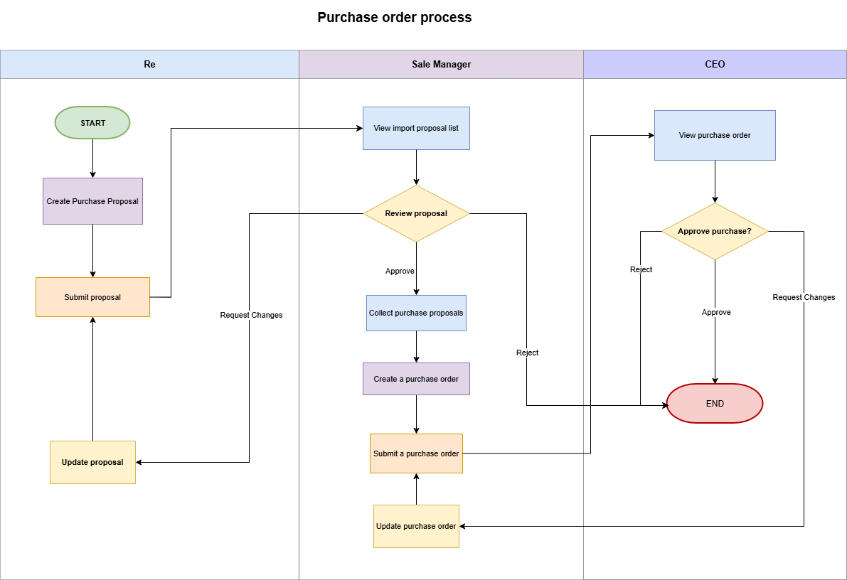
- State Diagram
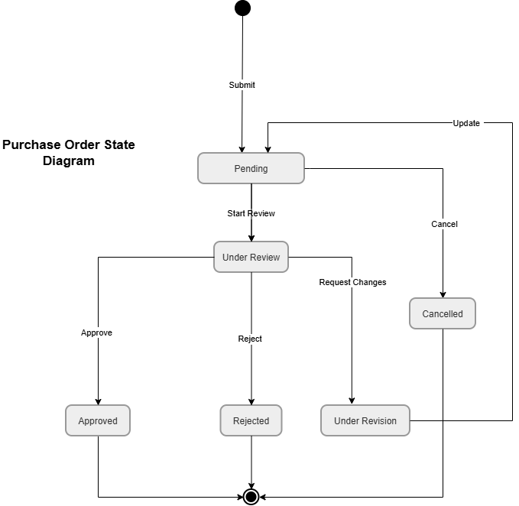
- ERD
